Smart Contracts

# Account

Firstly, we need to understand what is the Ethereum account.

Accounts are the main building block for Ethereum ecosystem.

The account state consists of four components:

* nonce (a number that represents the exact number of transactions sent from the account’s address / is the number of contracts created by the contract account)
* balance (the number of Wei owned by this address)
* storageRoot (is a 256-bit hash of the root node of a Merkle Patricia tree that encodes the storage contents of the account)
* codeHash (is the code that gets executed should this address receive a message call)

An account on Ethereum looks like the one shown here:



Ethereum supports two types of accounts:

* Externally owned accounts (Users accounts, controlled by private keys)
* Contracts accounts (controlled by code)

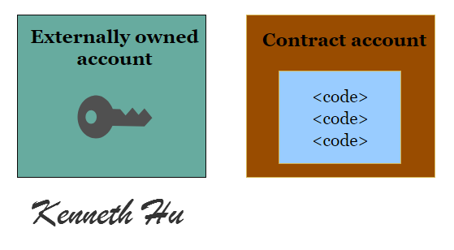

## Externally owned accounts (EOAs)

An externally controlled/owned account

* has an ether balance
* can send transactions (ether transfer or trigger contract code)
* is controlled by private keys
* has no associated code

## Contract accounts (some articles call it the Contract Wallet)

A contract

* has an ether balance
* has the associated code
* code execution is triggered by transactions or messages (calls) received from other contracts
* when executed — perform operations of arbitrary complexity (Turing completeness) — manipulate its own persistent storage, i.e., can have its own permanent state — can call other contracts

# Transaction

A transaction is an agreement between the buyer and the seller, the supplier and the consumer or the provider and the consumer that there would be exchange of assets, products or services in lieu of currency, crypto-currency or some other asset either in present or in future.

There are three types of transaction that can be executed in Ethereum:

* Transfer of Ether from one account to another. The accounts can be externally owned accounts or contract account.
* Deployment of Smart contract — An externally owned account can deploy a contract using a transaction in Ethereum virtual machine.
* Using or invoking a function within a contract — Executing a function in a contract that changes its state is considered as a transaction in Ethereum. If executing a function does not change the contract state, it does not require a transaction

## Fund Transfer Between EOA

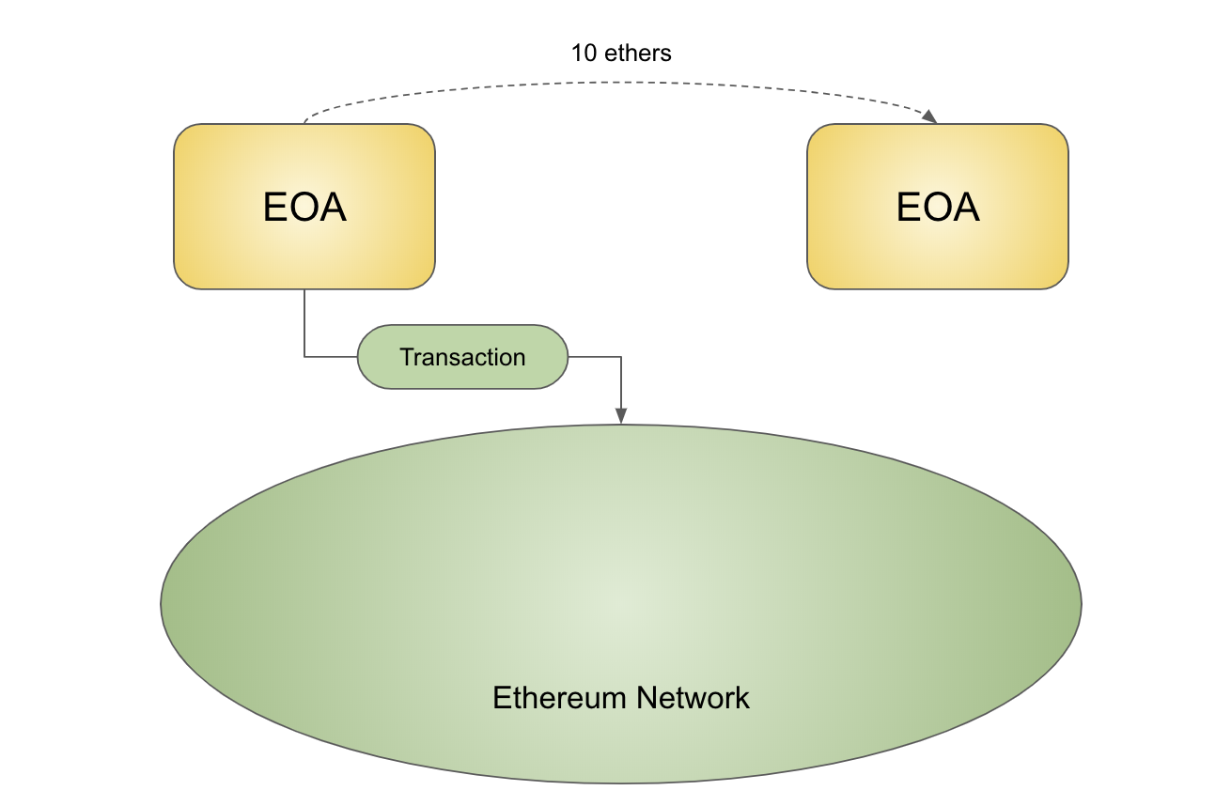

The transaction looks like this:

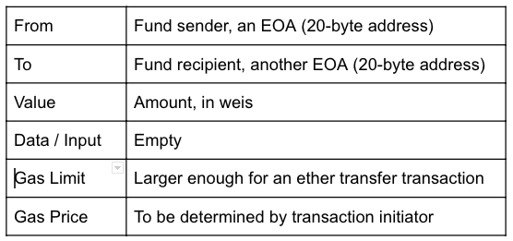

## Deploy a Contract on Ethereum Network

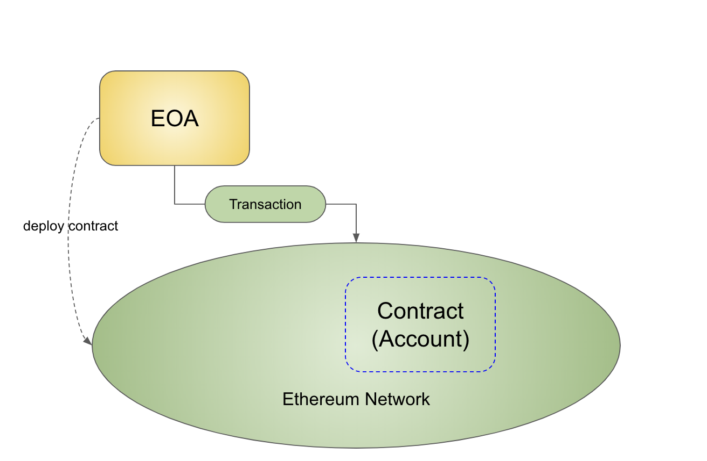

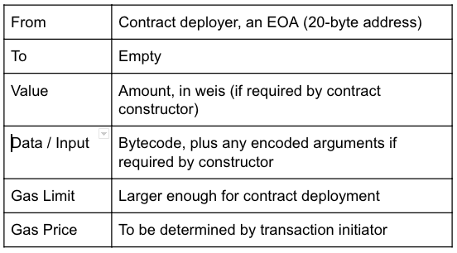

## Execute a Function on a Deployed Contract

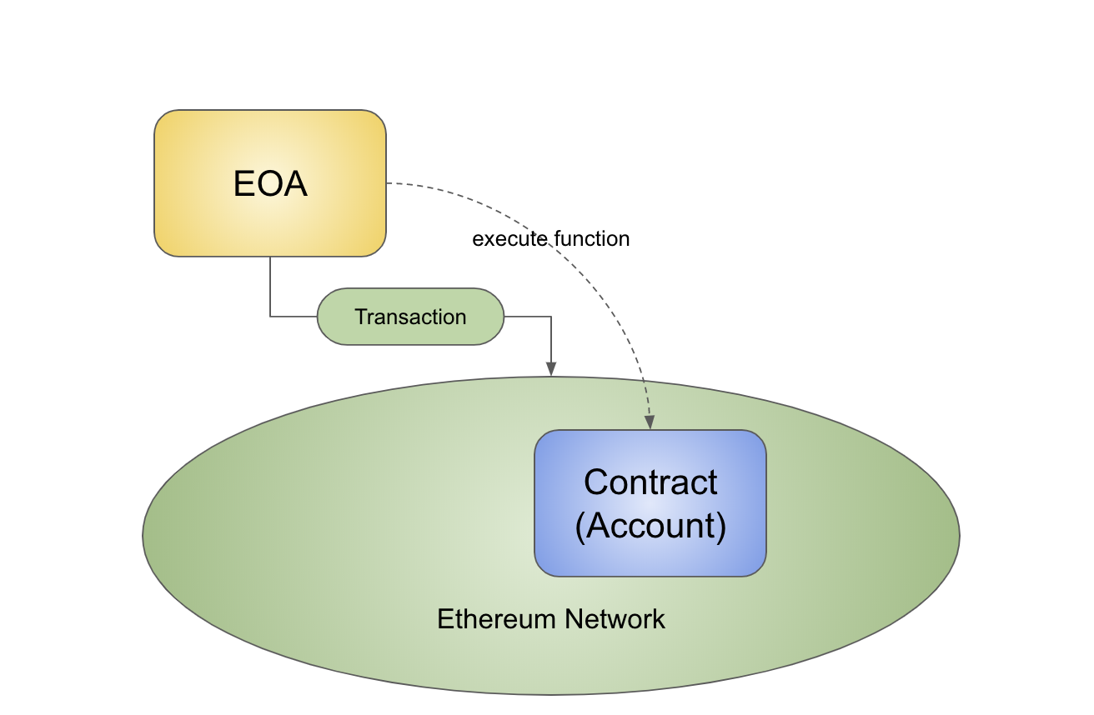

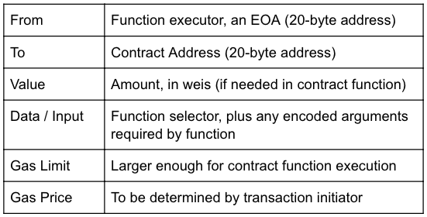

# Smart Contract

## Contract

A contract is a legal document that binds two or more parties who agree to execute a transaction immediately or in the future.

## Smart Contract

A smart contract is a contract implemented, deployed and executed within the Ethereum environment. Smart contracts can store data. The data stored can be used to record information, facts, associations, balances and any other things needed to implement logic for the real world contracts. Think of a smart contract as the small program consisting of functions. You can create an instance of the contract and invoke functions to view and update contract data along with execution of some logic.

## How to write Smart Contracts

Let’s try it!

We will need the MetaMask and Remix.

MetaMask provides the simplest yet the most secure way of connection to blockchain-based applications.

Remix is a Solidity IDE (Integrated Development Environment).

Let’s open Remix and write a simple smart contract.

There is Coin in a contract, it looks like an object.

Declare 3 variables: minter (the owner of the smart contract), countCoins and balances (the balances of the users)

We need to remember who deploys the smart contract.

Declare the initial count of coins. This count is set when we are deploying the smart contract.

Assign all of the coins to the minter.

Also we have 2 functions

sendTokens - used for sending tokens to the other user

and getTokens - used for getting count of tokens

Okay!))Smart contract is ready!

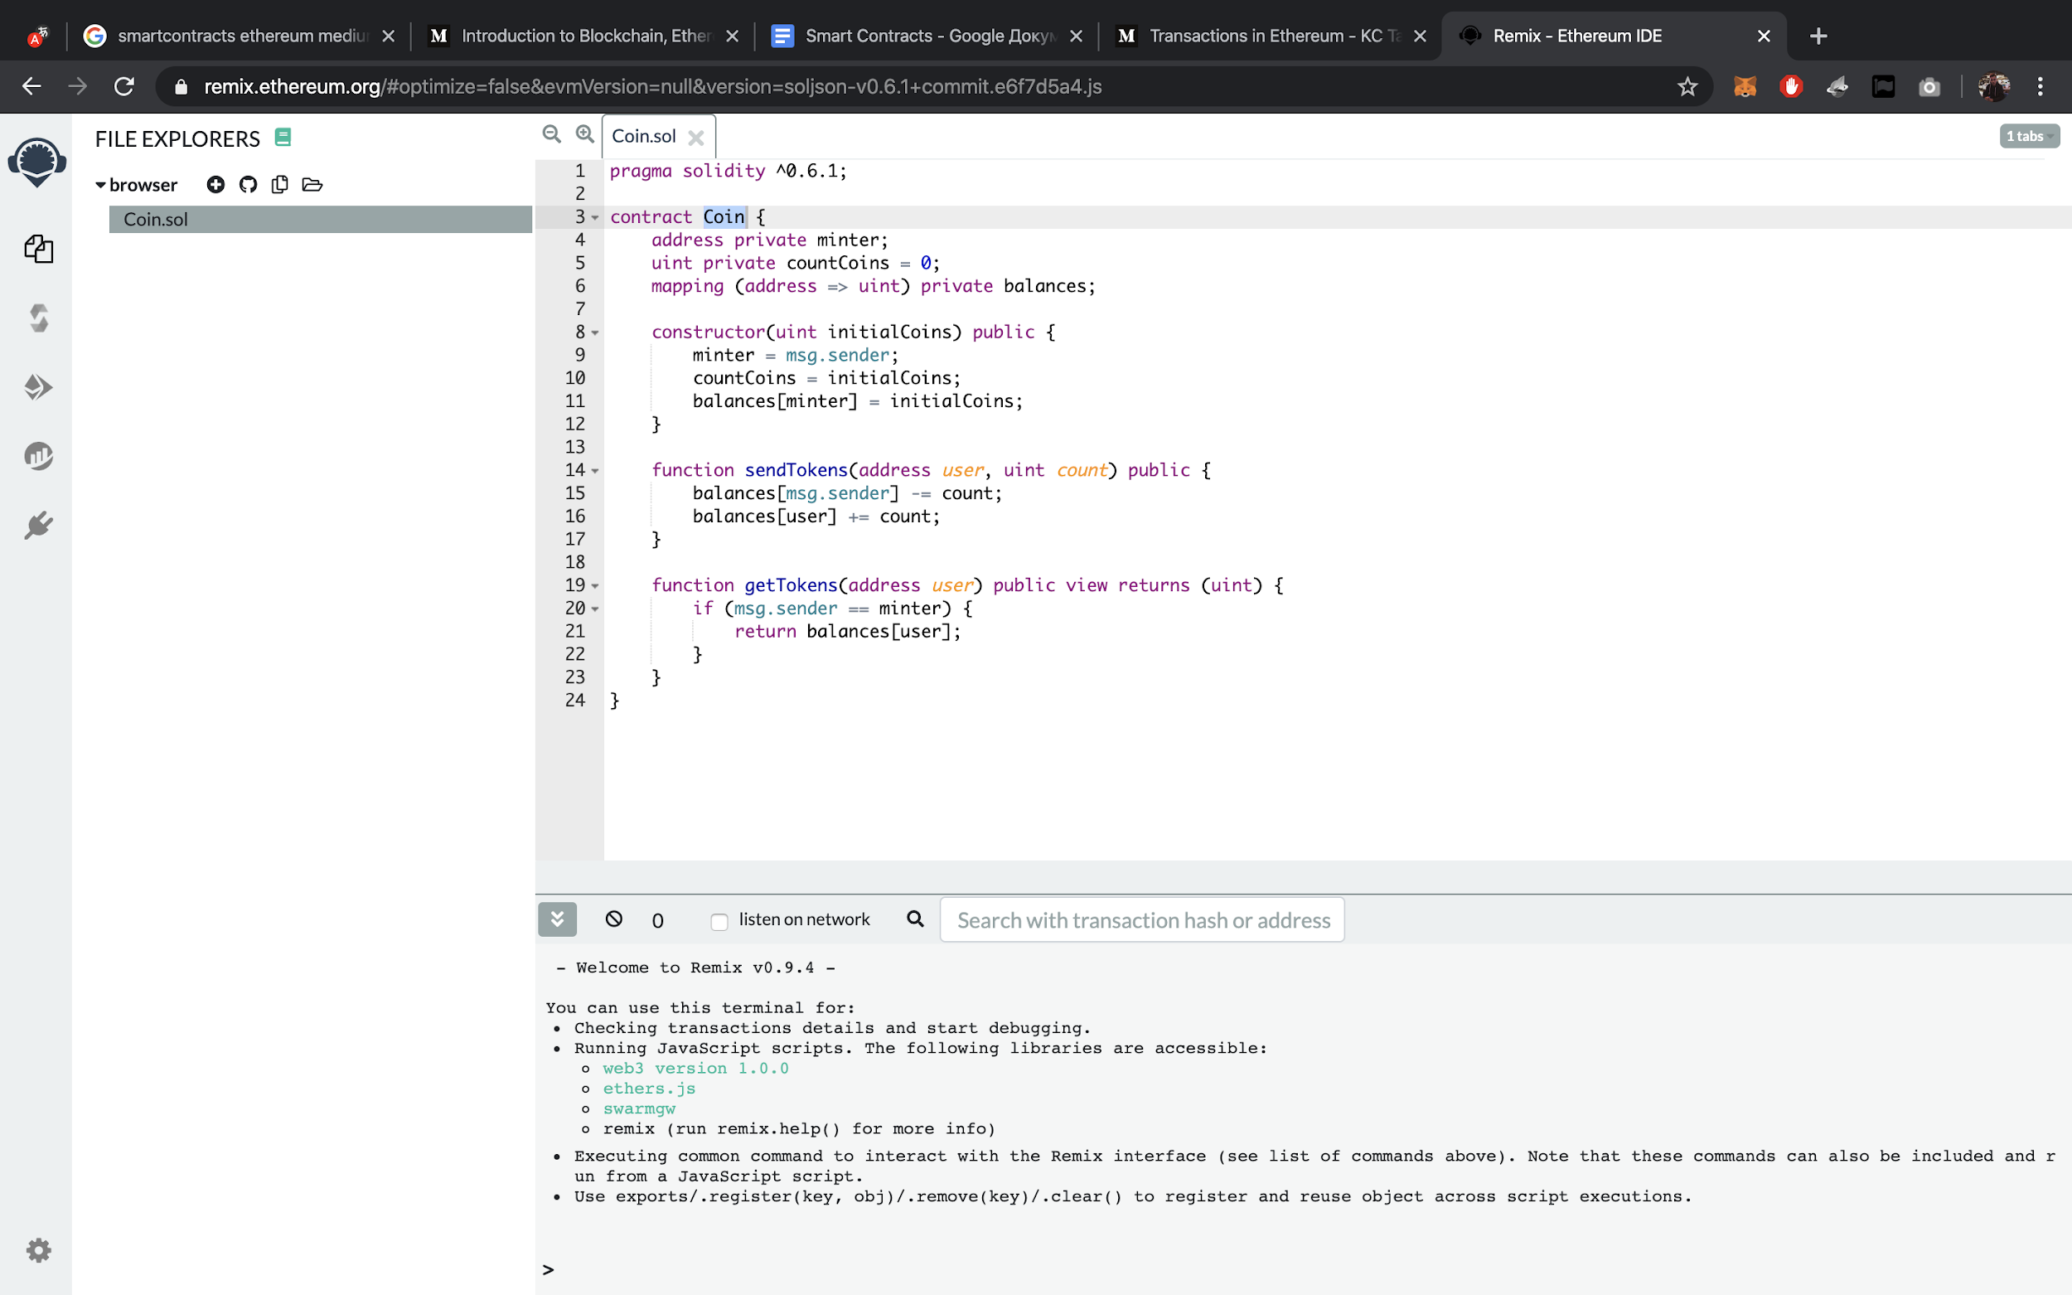

Now we can compile iit.

Everything was successful. And here we can see the details of this compilation.

The name of it, metadata, bytecode, ABI and so on.

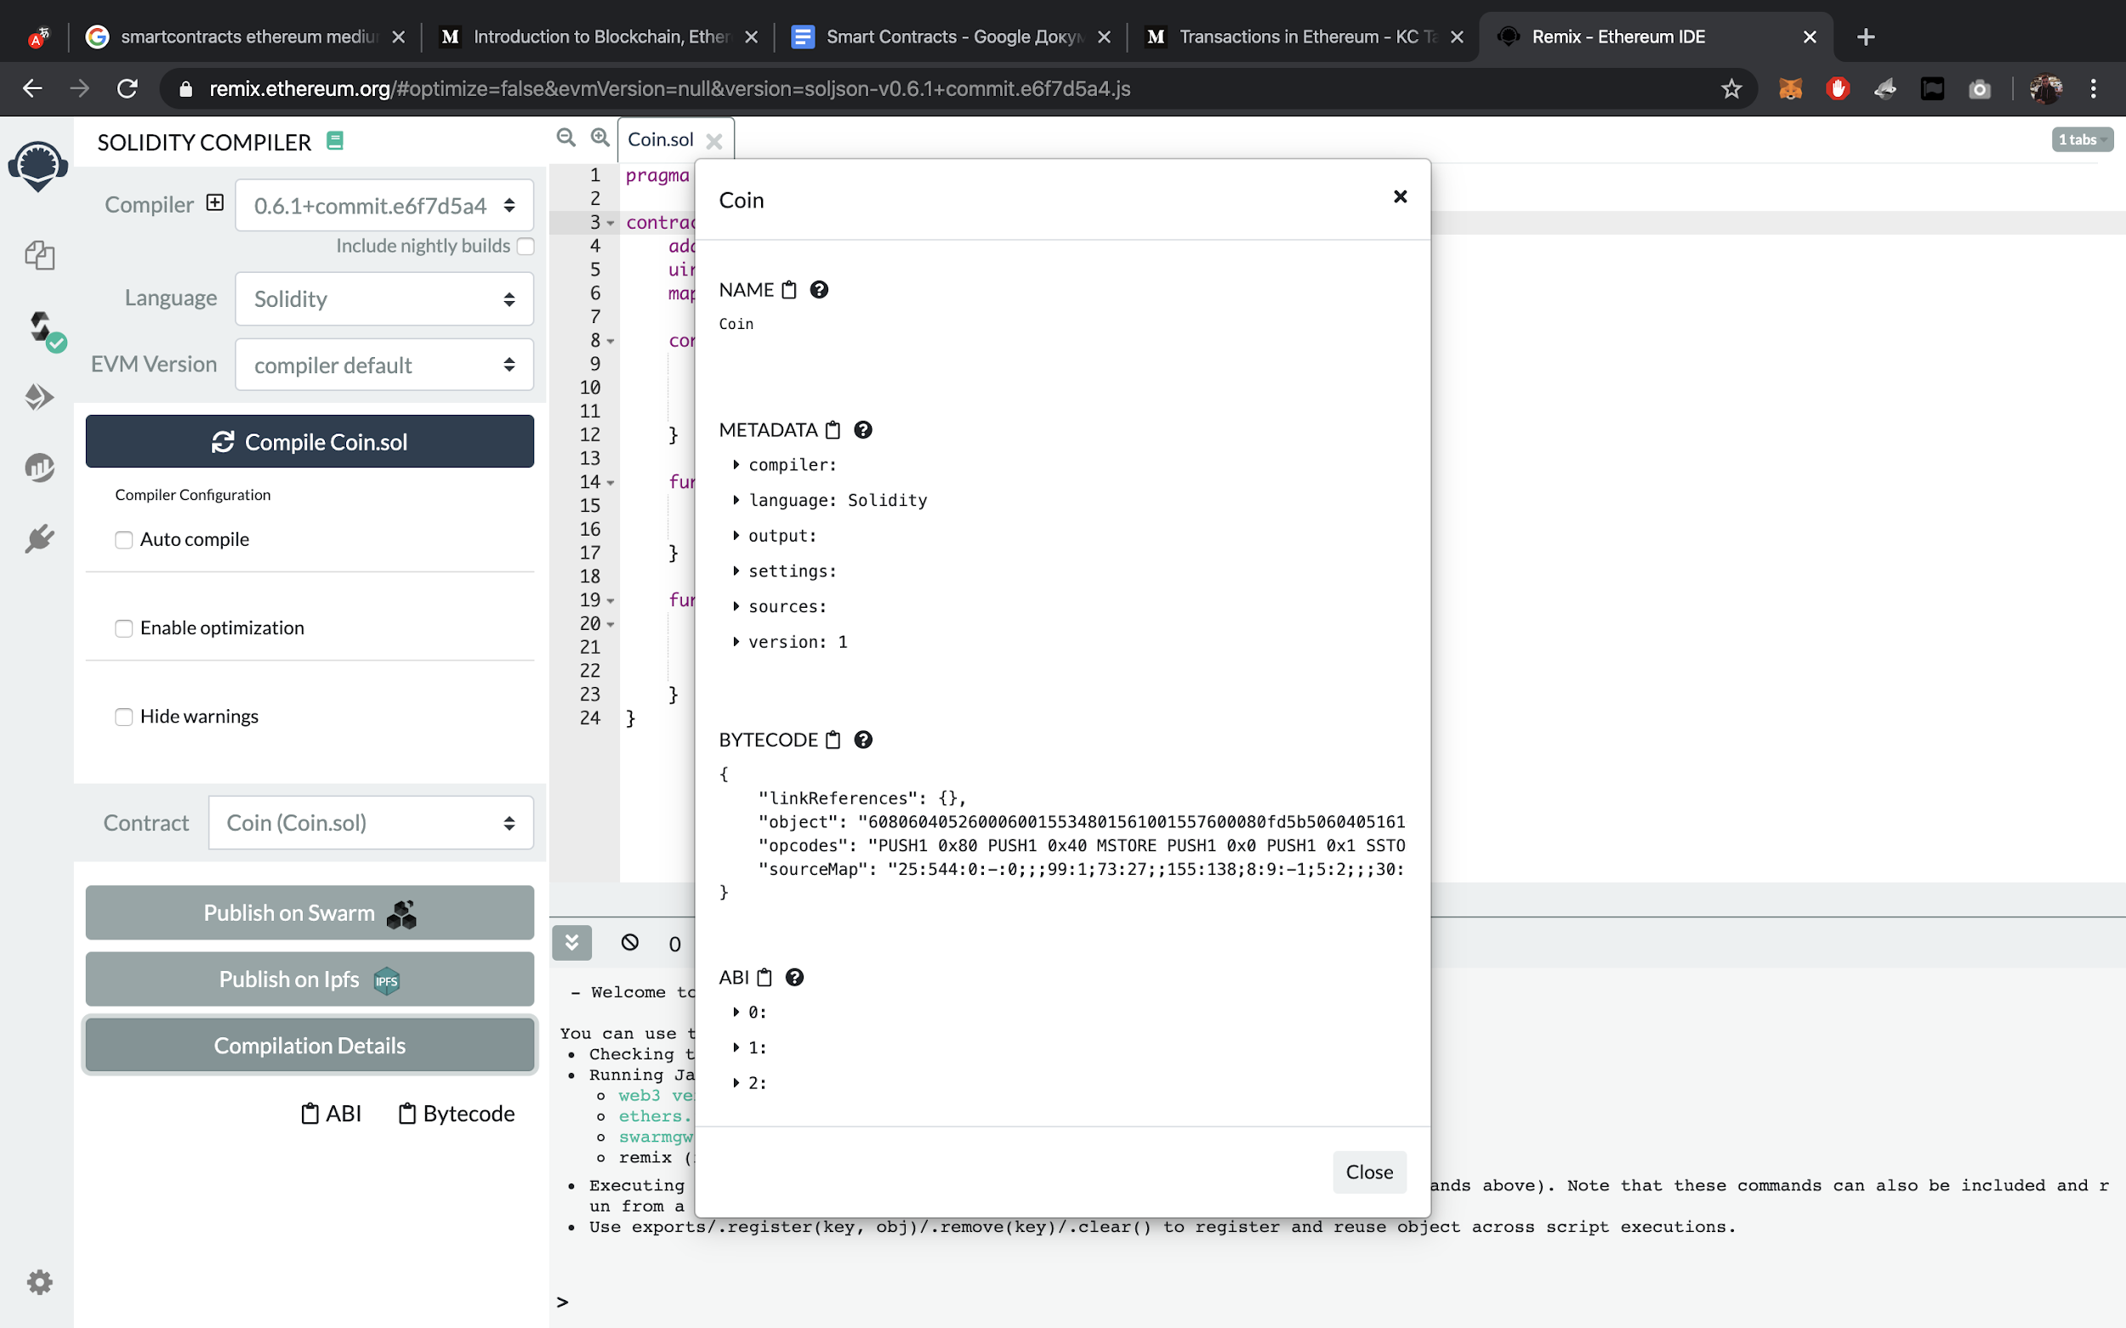

Next we will need to link our Ethereum wallet to this interface.

When MetaMask opens we need to allow the access.

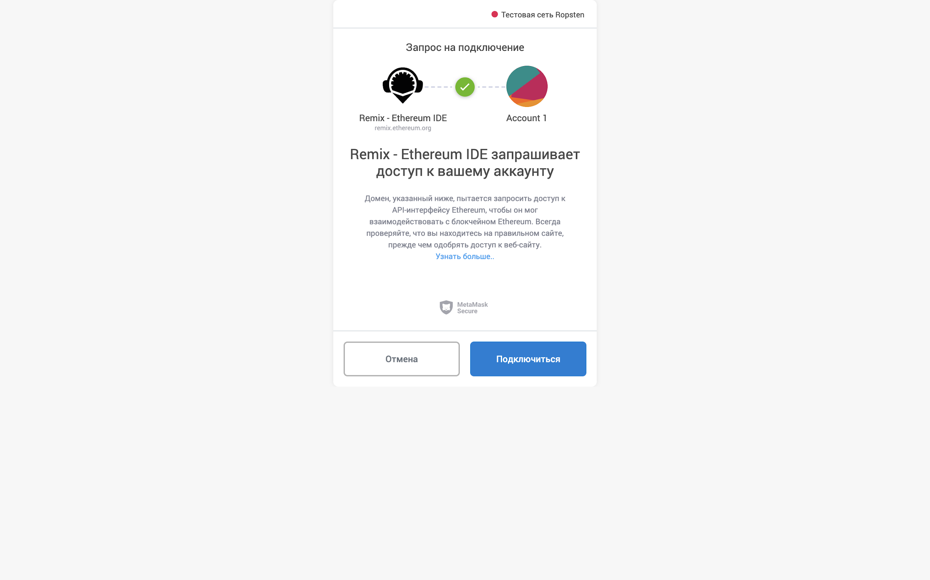

We see that the wallet address in MetaMask and in Remix are matching - it’s a success!

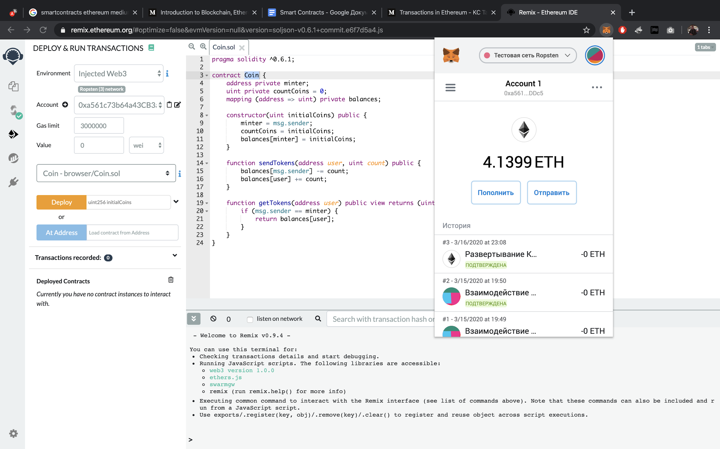

Let's deploy a smart contract.

We need to specify the initial count of coins.

And then click Deploy

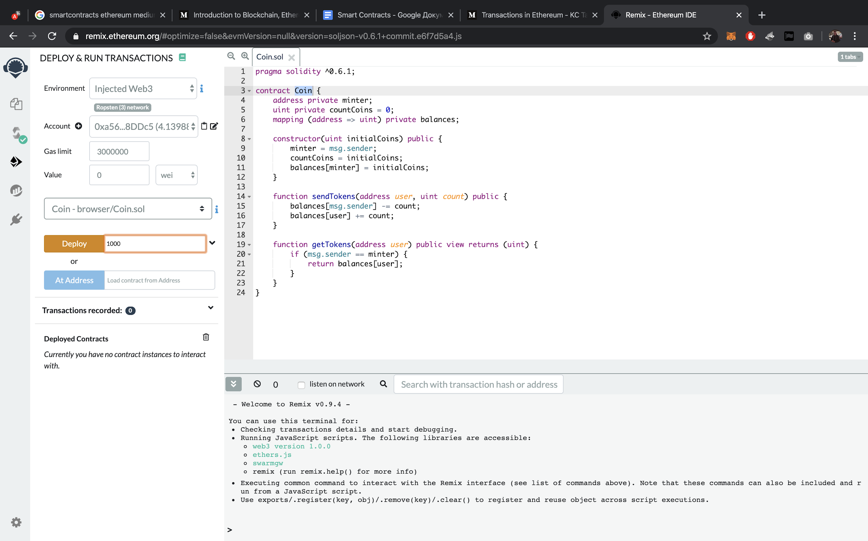

Application request for the operation opens

We need to click confirm

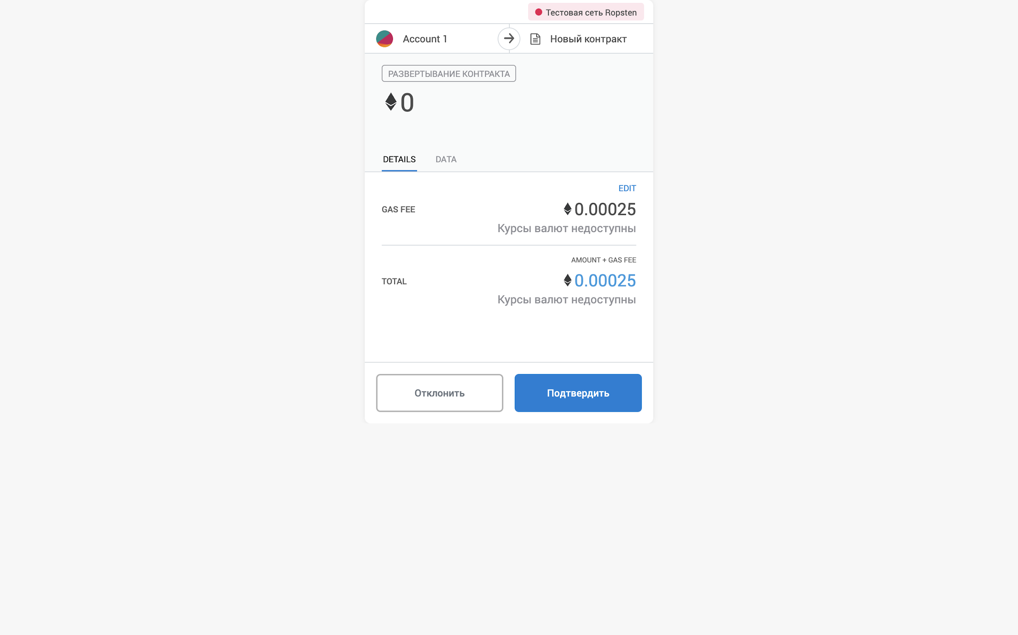

And here we can see this operation in the Chrome extension.

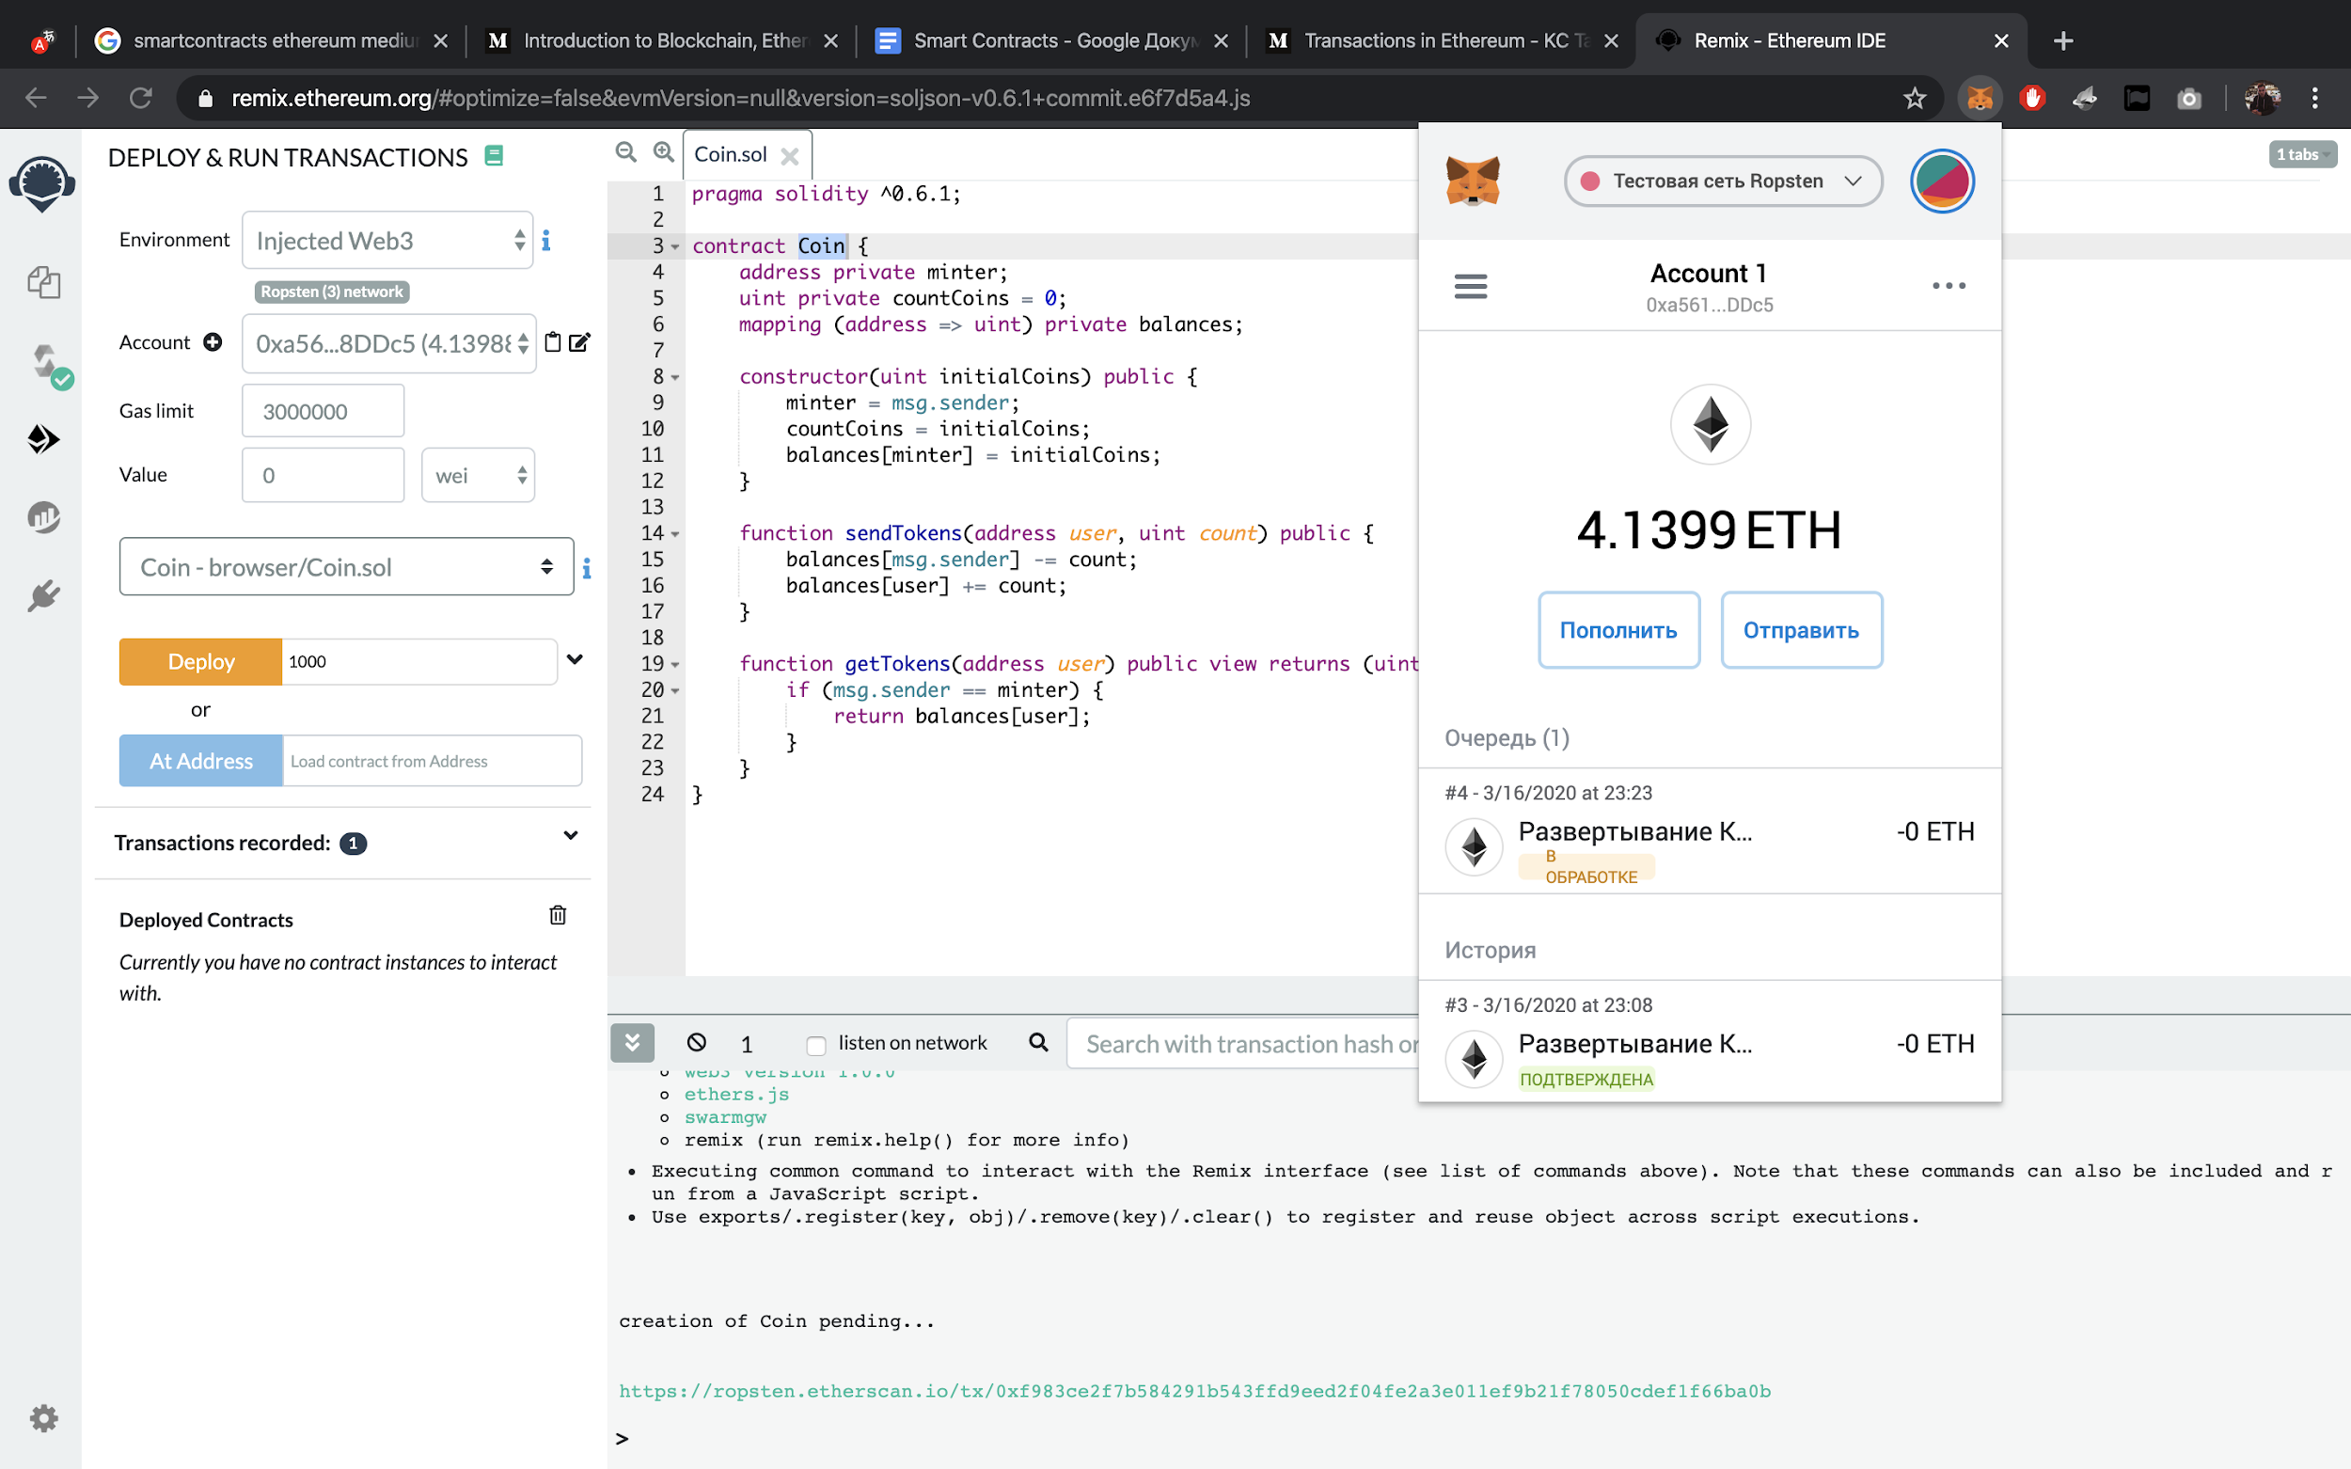

We have received a notification about 4 confirmations

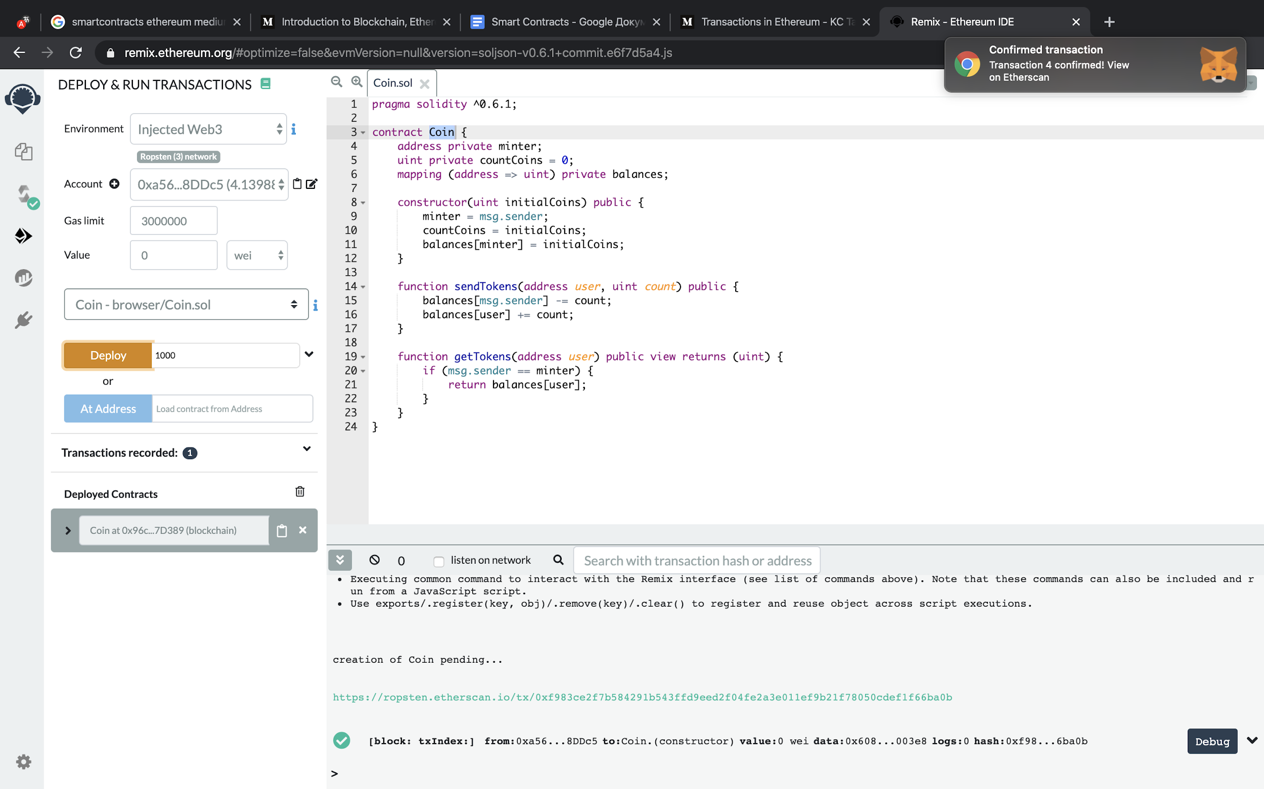

This means that the smart contract was successfully deployed.

And here we see 2 functions of this smart contract that we can call. And any other member from the Ethereum network.

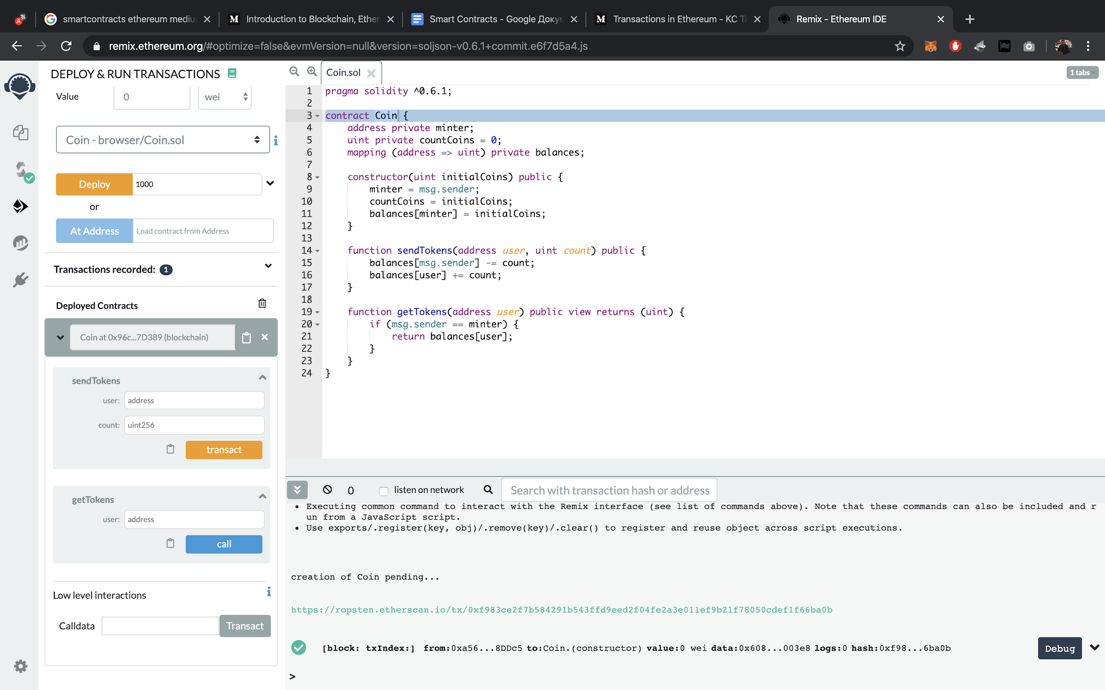

Okay. I have 2 accounts.

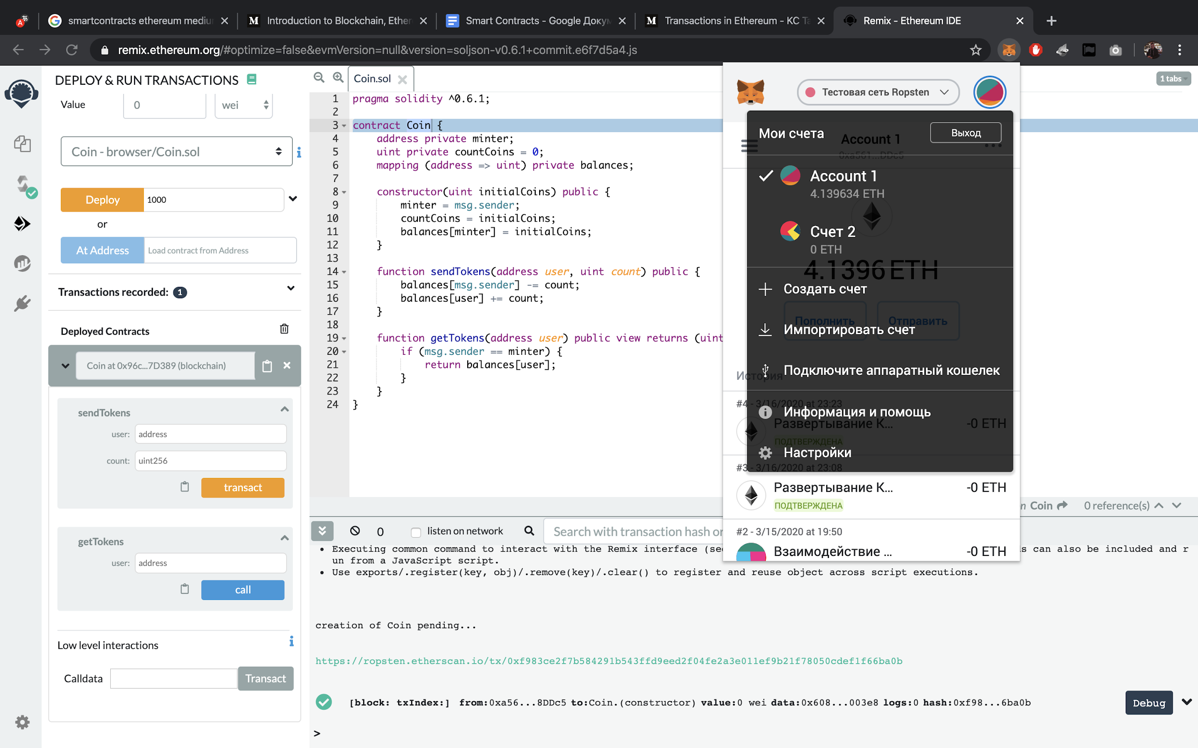

And now I want to send fifty tokens to my second account.

I should specify this in the field below and click transact.

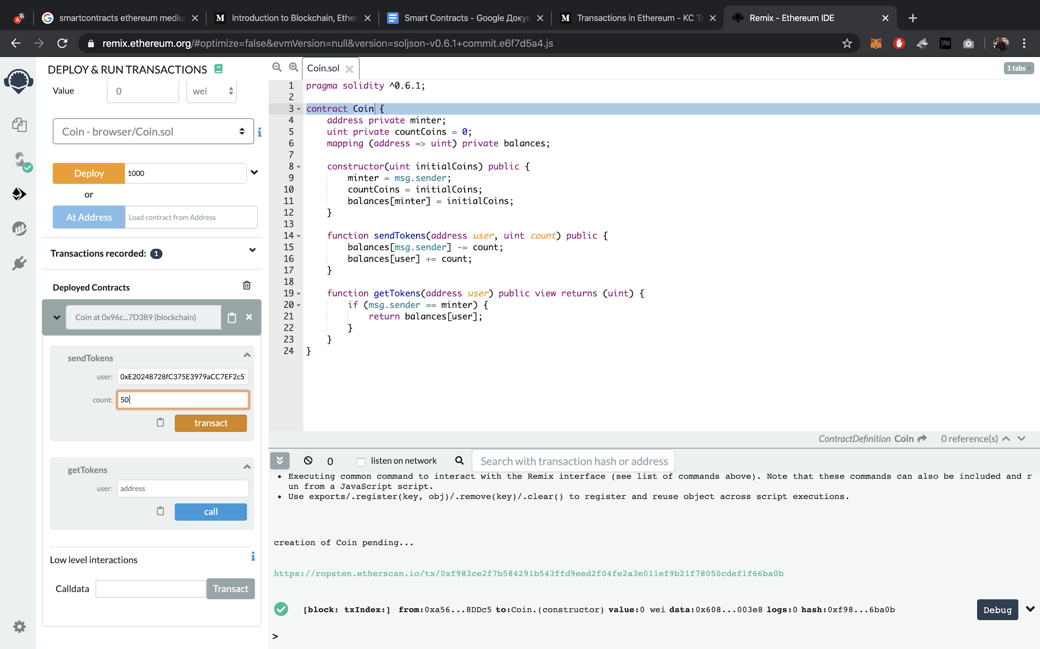

I need to confirm the request.

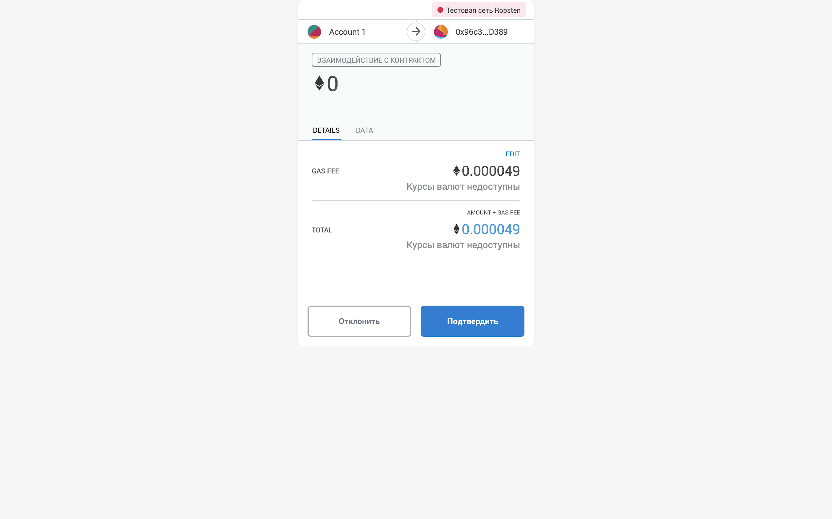

We can see that this request is in progress

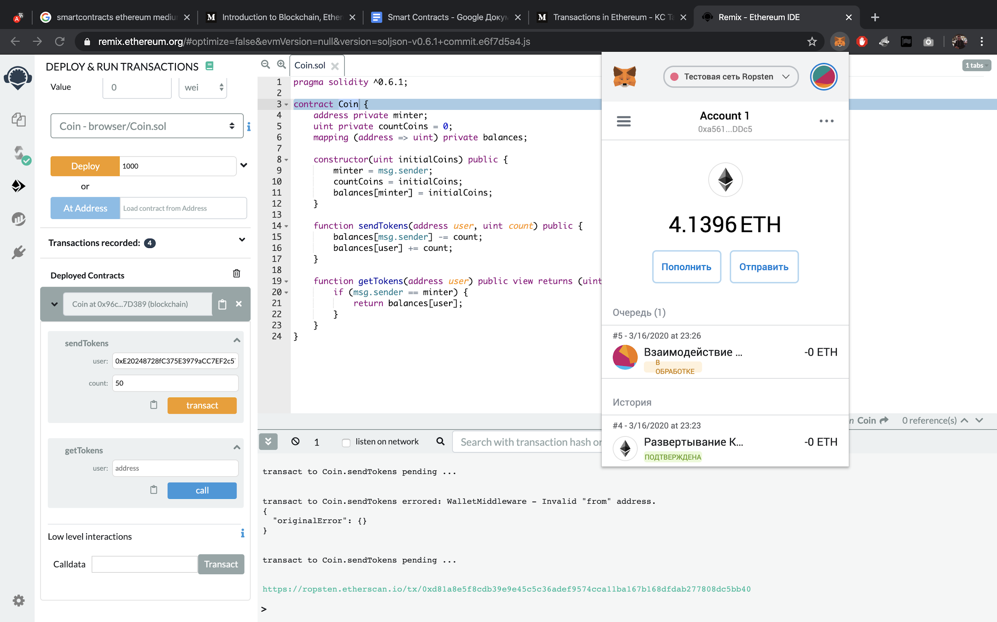

This is the detailed information about the request in the Ethereum network

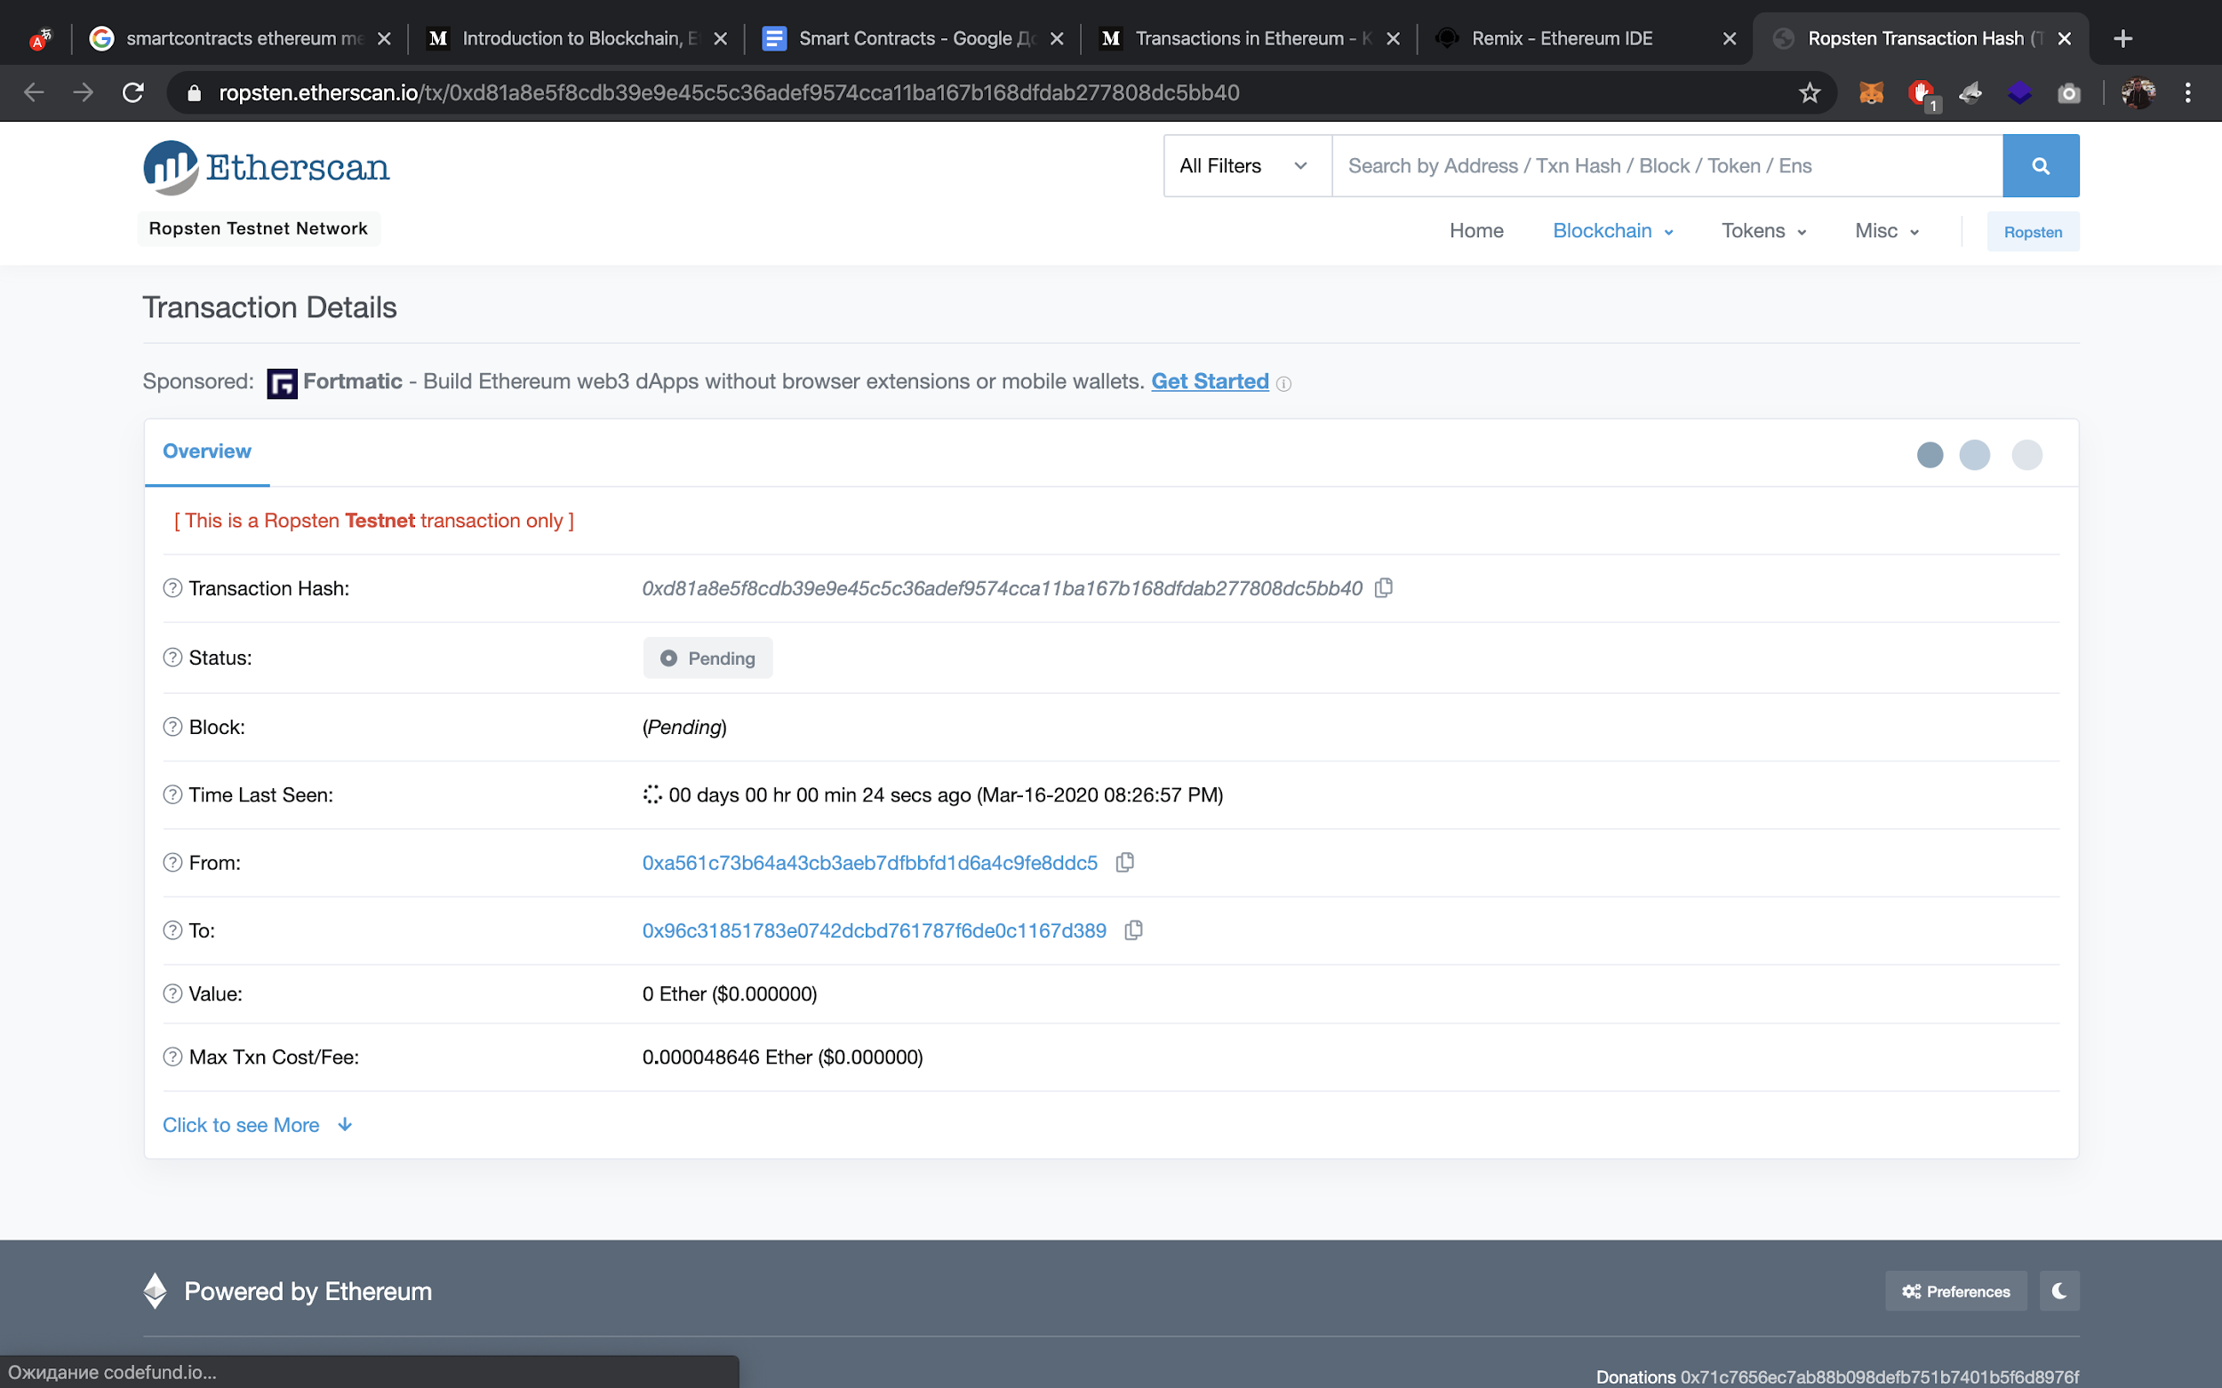

After a little while we receive a notification that the transaction has been completed.

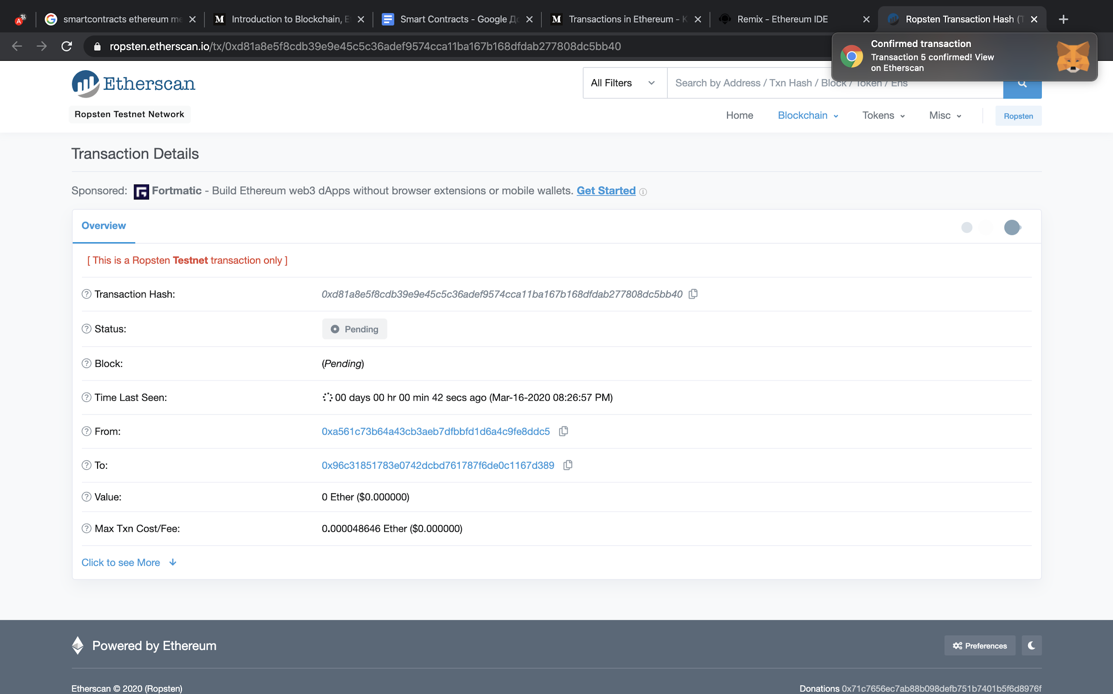

This is the updated information about our transaction.

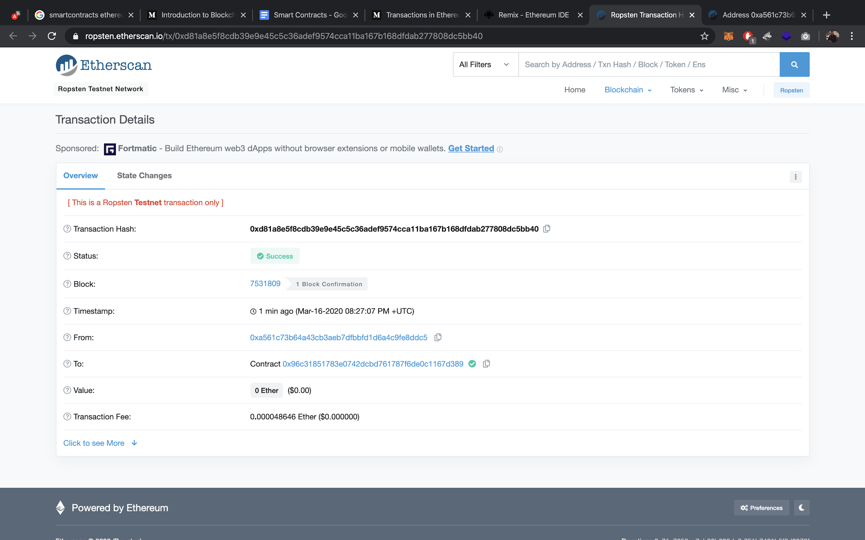

And now we can check the balance on both of my accounts.

The balance check function does not require a transaction, so we get a response immediately and without extra charges or fees.

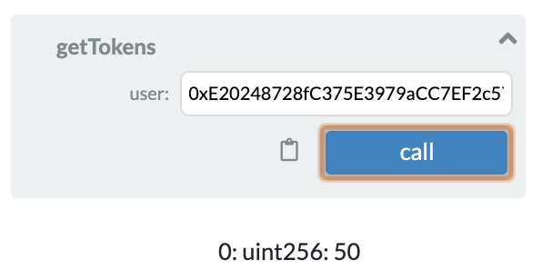

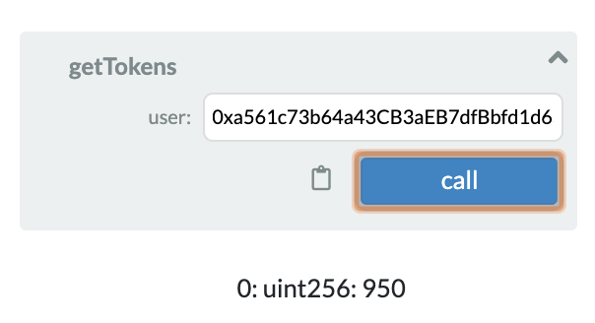

It works!

And additionally, now we can see how my account looks like on the Ethereum network. It is the first type of possible accounts - Externally owned account.

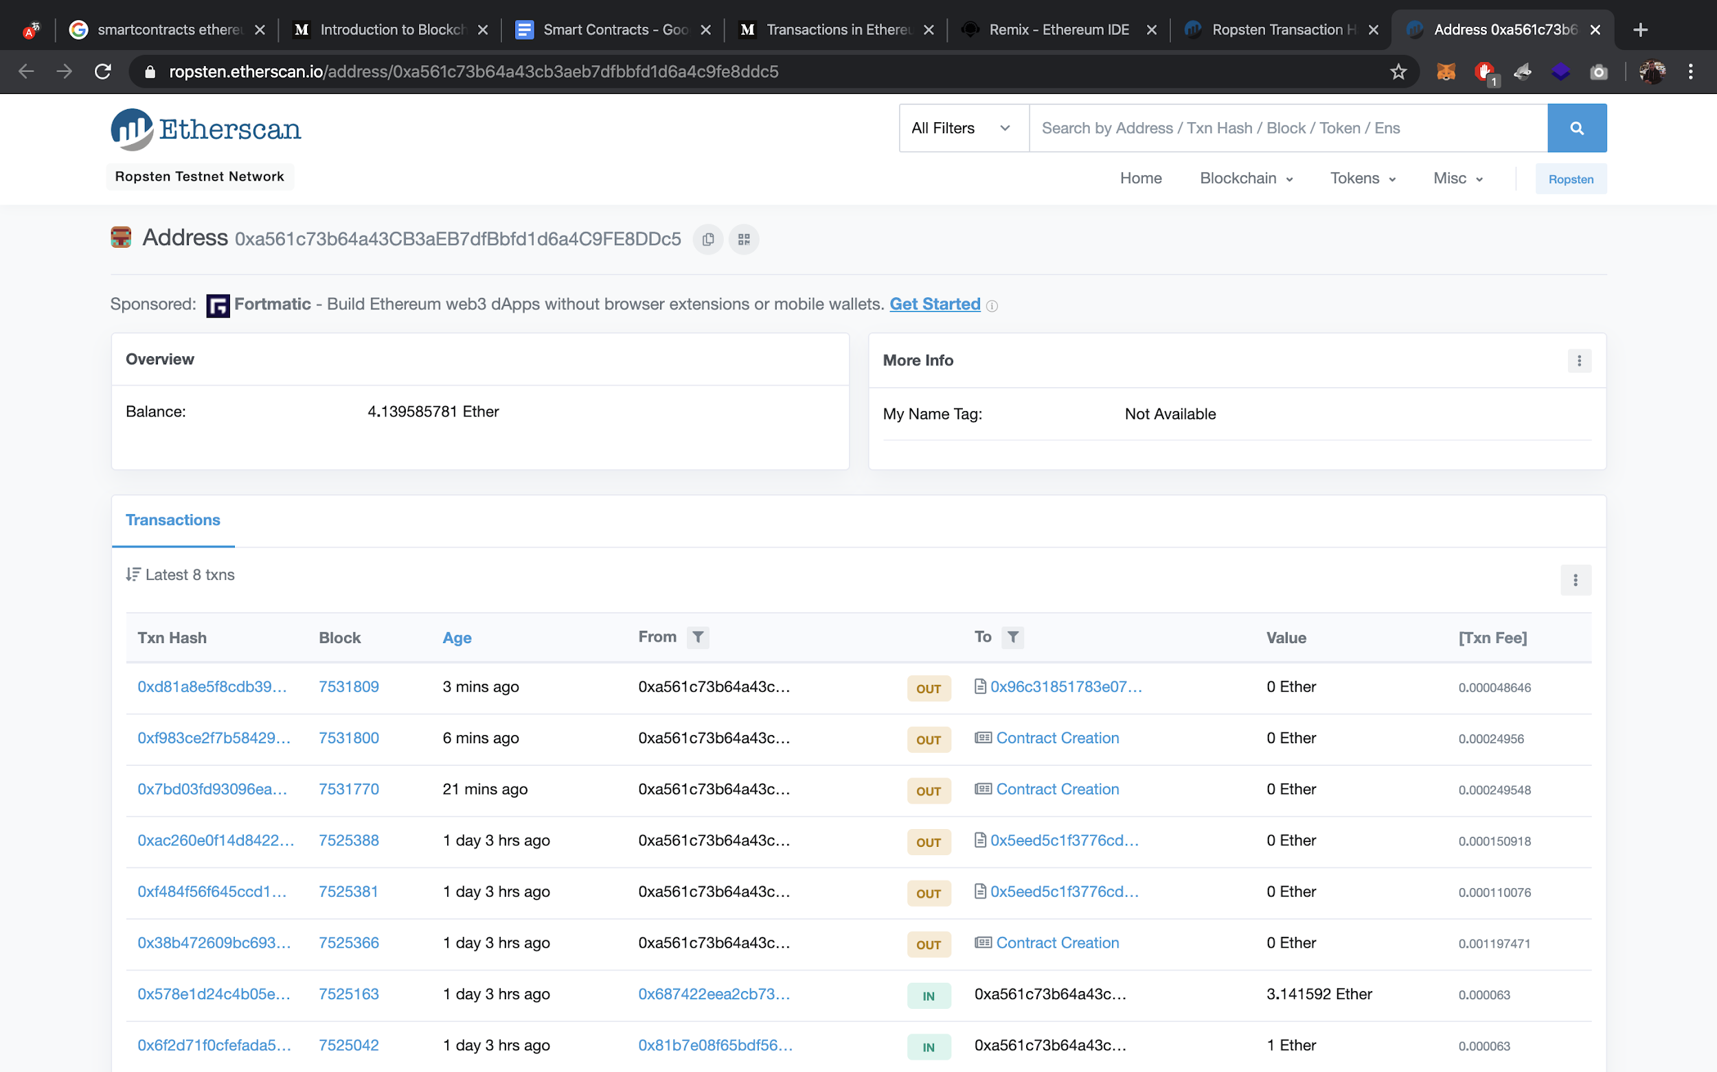

And this is the contract account.

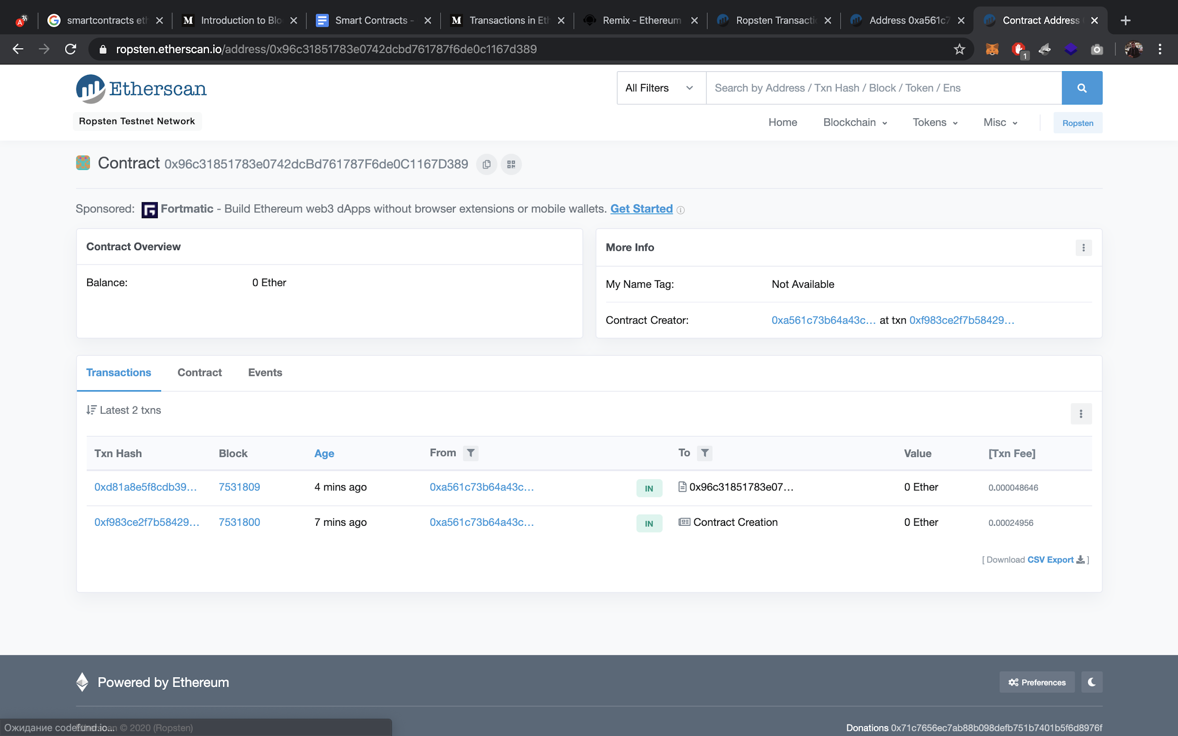

That’s all! Thanks for your attention. ;)

❤